Appendix II
Key features of the RoboCup NAO 4

New ATOM head:
- Intel Processor:
  - Intel® Atom™ Processor Z530
  - (512K Cache, 1.60 GHz, 533 MHz FSB)
  - HyperThreading
  - Instruction Set: 32-bit
  - Instruction Set Extensions: SSE2, SSE3, SSSE3

- 1GB of DDR2 RAM
- 2GB of SATA Flash
- Minimum of 8 Go micro-SD Flash
- 2x HD Cameras (1280x960)

 | V3.3 | NAO 4
Pixel size | 3.6µm x 3.6µm | 1.9µm x 1.9µm
Resolution & fps | Up to VGA@30fps | Embedded frame rates:  1280x960@30fps  640x480@30fps
Sensitivity per pixel | 1.3V/(Lux.sec) | 2.24V/(Lux.sec)

  - Features:
    - Digital or analog binning
    - 4x more sensitivity than v3.3

Figure 1: More sensitivity

    - Camera Diagonal Field of View: increased and overlapping

Figure 2: Increased and overlapping Field of View
    - Dedicated and non-programmable FPGA: 2 simultaneous video streams
    - Rolling shutter issues divided by 2.5
    - Low noise levels

- Head thermal management:
  - New Fan: 2x more airflow
  - Airflow control redesign

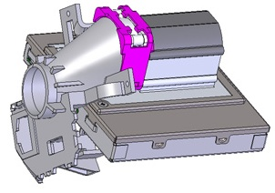
Figure 3: Temperature Controlled Fan with laminar forced convection
- New Skull/brain paradigm
  - Shock absorbers
  - New connectors with high misalignment tolerances

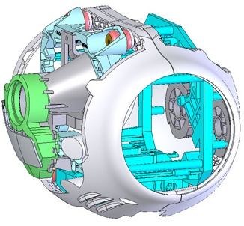
Figure 4: Shock absorbers (red arrow)

Body improvements:

- New spherical joints:
  - Better force distribution
  - Better elasticity coefficient

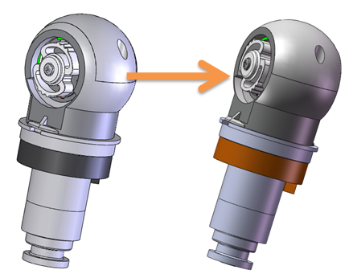
Figure 5: New spherical joints

- New motor boards (torso and legs) to improve motor thermal management: this improvement is in testing process and therefore subject to approval by the qualification team.
- Lighter robot due to new motor Better motor integration

