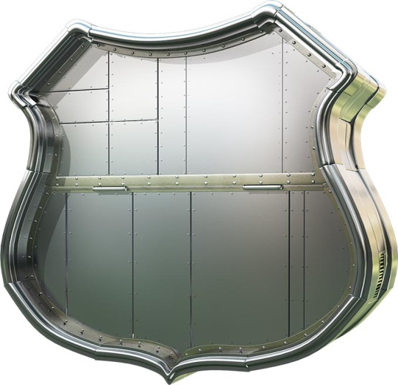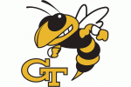
Union Pacific Railroad Tailgate
WHEN: October 20, 2012
WHERE: Top Level of Peter's Parking Deck
TIME: 1:00 PM
Meet Engineering and IT representatives from Union Pacific
Prizes and Refreshments
Georgia Tech
vs
Boston College
3:00 PM Game Start

