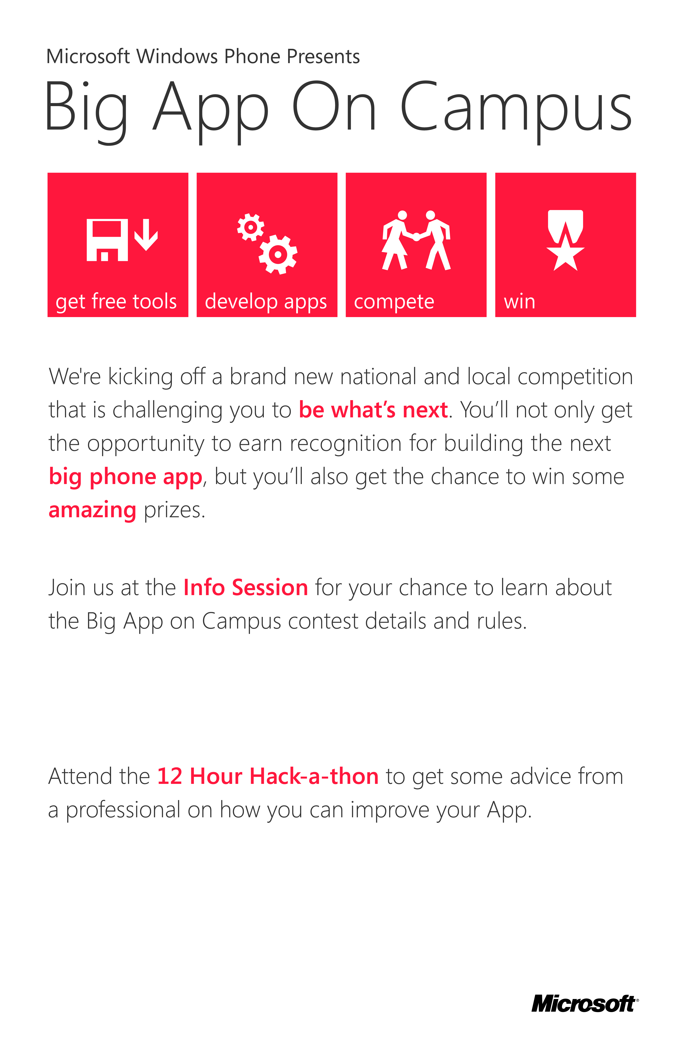
When? Saturday, January 21st 10:00 AM-10:00 PM
Where? College of Computing building, room 17
When? Thursday, January 19th 6:00-8:00 PM
Where? Bldg #153 Klaus, room 2443

